Muhammad Anas
25k-0899 Fast university
OOp Lab task 9

TASK

Task1:
#include<iostream>
using namespace std;

class Transaction {
public:
string accountNumber;
double amount;

Transaction(string a, double val) {
accountNumber = a;
amount = val;
}
virtual void processTransaction() = 0;
virtual ~Transaction() {}
};

class Deposit: public Transaction {
public:
double valueToBeDeposited;
Deposit(string a, double val, double init=0) : Transaction(a, init) {
valueToBeDeposited = val;
}
void processTransaction() {
cout << "Deposit Transaction" << endl;
cout << "Account: " << accountNumber << endl;
cout << "Previous Amount: " << amount << endl;
amount += valueToBeDeposited;
cout << "Current Amount: " << amount << endl;
cout << "Status: Amount Deposited Successfully" << endl;
}
};

class Withdrawal: public Transaction {
public:
double amountToBeWithdrawn;

Withdrawal(string a, double val, double amount) : Transaction(a, amount) {
amountToBeWithdrawn = val;
}

void processTransaction() {
cout << "Withdrawal Transaction" << endl;
cout << "Account: " << accountNumber << endl;
cout << "Previous Amount: " << amount << endl;
if (amount-amountToBeWithdrawn>=0) {
amount-=amountToBeWithdrawn;
cout << "Current Amount: " << amount << endl;
}
else {
amount=0;
cout << "Amount = 0 (negative amount cannot exist)" << endl;
}
cout << "Status: Withdrawn successfully" << endl;
}
};

class Transfer: public Transaction {
public:
double amountToBeTransferred;
string accountToBeTransferredTo;

Transfer(string a, double val, double amount, string c) : Transaction(a, val) {
amountToBeTransferred=amount;
accountToBeTransferredTo = c;
}

void processTransaction() {
cout << "Transfer Transaction" << endl;
cout << "Account to be Transferred to: " << accountToBeTransferredTo << endl;
cout << "Your Account Number: " << accountNumber << endl;
double output = (amount >= amountToBeTransferred) ? amountToBeTransferred : amount;
cout << "Previous amount(in your account): " << amount << " | ";
if (amount-amountToBeTransferred>=0) {
amount-=amountToBeTransferred;
cout << "Current Amount(in your account): " << amount << endl;
}
else {
amount=0;
cout << "Amount = 0 (negative amount cannot exist)" << endl;
}
cout << "Total Amount Transferred: " << output <<endl;
cout << "Status: Amount Transferred Successfully" << endl;
}
};

int main () {
Transaction* t;

// Deposit: Initial 5000, depositing 5000 more
Deposit d1("12345", 5000, 5000);
t = &d1;
t->processTransaction();

cout << endl << endl;

// Withdrawal: Current 10000, withdrawing 2000
Withdrawal w1("12345", 2000, 10000);
t = &w1;
t->processTransaction();

cout << endl << endl;

// Transfer: From account 12345 with 8000, transferring 1500 to 54321
Transfer tr1("12345", 8000, 1500, "54321");
t = &tr1;
t->processTransaction();

return 0;
}

Output:
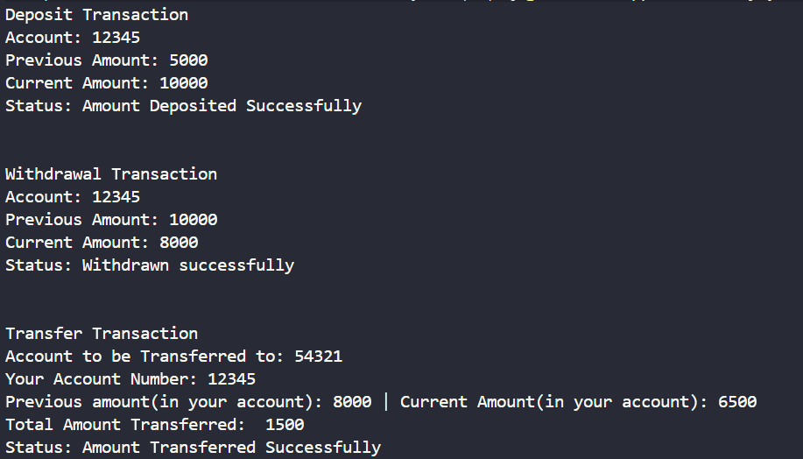

Task 2
// // Task 2: Smart Notification System
// Description
// Design a notification system used in modern applications like mobile apps or web platforms.

#include <iostream>
#include <string>
using namespace std;

class Notification {
protected:
string recipient;

public:
Notification(string recip) : recipient(recip) {}

virtual ~Notification() {}

virtual void sendNotification() = 0;
};

// Email notification class
class EmailNotification : public Notification {
private:
string message;
string subject;

public:
EmailNotification(string recip, string subj, string msg)
: Notification(recip), subject(subj), message(msg) {}

void sendNotification() override {
cout << "Email Notification" << endl;
cout << "To: " << recipient << endl;
cout << "Subject: " << subject << endl;
cout << "Message: " << message << endl;
cout << "Status: Sent Successfully" << endl;
}
};

// SMS notification class
class SMSNotification : public Notification {
private:
string message;

public:
SMSNotification(string recip, string msg)
: Notification(recip), message(msg) {}

void sendNotification() override {
cout << "SMS Notification" << endl;
cout << "To: " << recipient << endl;
cout << "Message: " << message << endl;
cout << "Status: Sent Successfully" << endl;
}
};

// Push notification class
class PushNotification : public Notification {
private:
string title;
string body;

public:
PushNotification(string recip, string ttl, string bdy)
: Notification(recip), title(ttl), body(bdy) {}

void sendNotification() override {
cout << "Push Notification" << endl;
cout << "To: " << recipient << endl;
cout << "Title: " << title << endl;
cout << "Body: " << body << endl;
cout << "Status: Sent Successfully" << endl;
}
};

int main() {
// Create different notification objects
EmailNotification email("user@example.com", "Welcome", "Welcome to our platform!");
cout << endl;
email.sendNotification();

cout << endl << endl;

SMSNotification sms("03001234567", "Your OTP is 1234");
sms.sendNotification();

cout << endl << endl;

PushNotification push("user_device_123", "New Message", "You have a new message from John");
push.sendNotification();

return 0;
}

Output:
